


Scope and Storyboard for Trial

AMR, Manchester

By GQL

Table of Contents

1. Document Revision History 2
1.1. Document Location 2
1.2. Revision History 2
1.3. Approvals 2
1.4. Distribution 2
2. Summary of Scope 3
3. Screen design 3
4. Workflow 5
5. Navigation 6
5.1. Where will the Flow be launched from 6
5.2. Where should the Flow return to 6
6. SQL Tables 6
6.1. Table 6
6.2. Lookup 7
6.3. Field 7
7. Stored Procedures 7
7.1. Fetch 7
7.2. Save 7
8. Document Templates 8

Document Revision History

Document Location
Full File Path
\\Man05sql\Dev\Applications\Flosuite\Scopes\HTMM\Scope and Storyboard Trial\2011-06-29 FL017 Scope and Storyboard_Trial V2.doc

Revision History
Version Number | Revision Date | Summary of Changes | Changes marked | Author
0.1 | 09/02/2010 | First issue | N/A | GQL
0.2 | 29/06/2011 | Update for Requirements Gathering | N/A | GQL
0.3 | 25/07/2011 | Update from Requirements Gathering | No to many | GQL

Approvals
Name | Signature | Title | Date of Issue | Version

Distribution
Name | Title | Date of Issue | Version

Summary of Scope

The purpose of this scope is to outline the provisions that the FloCase system will need to handle the process of preparing for a Trial and dealing with its outcome.

The main hub of this will be a pre-trial checklist task that will be scheduled for the Fee Earner but with the intention of being completed as a pre-trial review with the supervisor of the matter.

Screen design

  - Pre-Trial Preparation

Form Availability

The pre-trial checklist will be scheduled automatically for the Lawyer upon the insertion of a trial date or trial window key dates(s) upon the FloCase system via the Directions tab. It will be scheduled for 8 weeks before either the trial date entered or beginning of the trail window with a view of the Lawyer completing the activity as part of a pre-trial review with the Supervisor on the matter. The activity should escalate to the supervisor 1 week before the trial date entered.

Form Behaviour On Load

The form should load with the selected Court and either the Trail Date or Trial Window from the directions tab pre populated via a new stored procedure LTMM_PreTrialPrep_Fetch.

Form Items

The pre-trial checklist screen will be split into five tabbed sections, Directions Summary, Lay Witness Summary, Expert Witness Summary, Counsel Summary and Quantum and Liability Review and will look like the following diagrams with controls.

In addition to these 5 tabbed sections the following controls will be visible at the top of the form regardless of the tab selected:
Court – Label as stated with associated read only textbox displaying the court linked to the trial date/window key date(s) that spawned the Pre-Trial Preparation task.
Trial Date – Label as stated with associated date picker which will either display the start date of a trial window or the Trail date itself.
Trial Window? – Label as stated with associated checkbox that when checked displays an associated date picker that either displays the end date of the associated trail window key date or allows the user to enter a trial window end key date.
Reschedule? – Label as stated with associated checkbox that when checked displays an associated date picker that allows the user to enter a date that the task will be rescheduled on upon submission.

Trial Date and window functionality

The trail date/window key dates displayed on this screen should be intrinsically linked to the corresponding direction key dates attached to the Court displayed in the Court text box. If the user amends these dates from this screen the key dates on the direction tab should also be amended. Either a Trial date or a Trial Window must be entered upon submission of this form. Due to the nature of these key dates this form should not be available adhoc as it should be linked to the court that triggered its scheduling.

Form items for the tabs are listed in the subsequent sub sections 3.1.1 – 3.1.5 inclusive below.

Form Behaviour on Submit

Should return to the Matter Landing Page.

If Reschedule <> ‘’ – Schedule Pre-Trial Preparation for the Fee Earner on the Matter for the date entered in Reschedule

If Reschedule = ‘’ Write history line Pre-Trial Preparation Complete

If Reschedule = ‘’ schedule Record Trial Result for the Lawyer on the matter for either the Trail date or the Trial Window start date.

Use New Stored Procedure LTMM_PreTrialPrep_Save to save the following details entered on the form:
- Trial Date or Trial Window
- Plus other items listed in the subsequent sub sections 3.1.1 – 3.1.5 inclusive below.

Form Behaviour on Cancel

Return to the matter landing page.

    - Pre-Trial Preparation – Directions Summary Tab

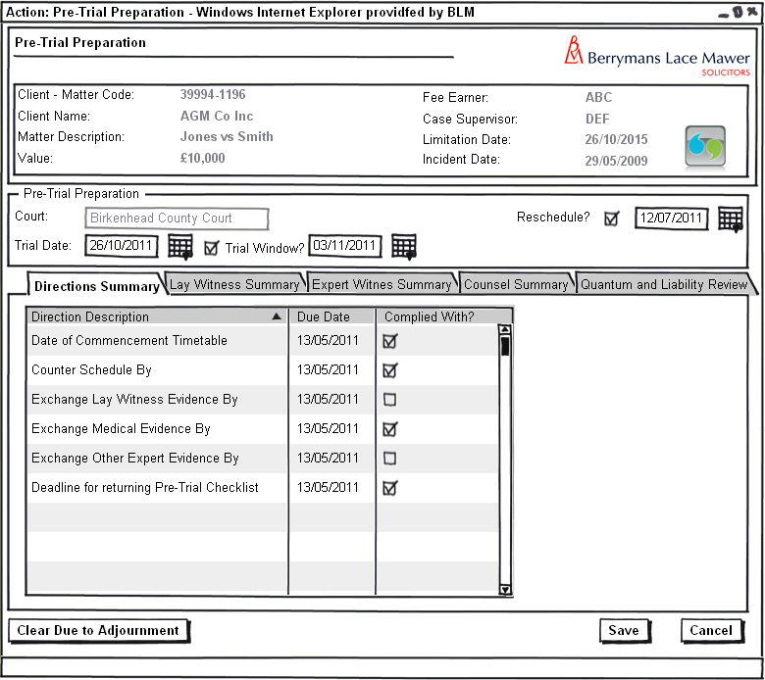
Figure 1 – Pre-Trial Preparation – Directions Tab

The directions summary above will allow the user to review all the court directions pre-trial and check them off as completed.

Form Items

Directions Summary - Grid listing all active directions attached to the court linked to the trial date/window key date(s) that spawned the Pre-Trial Preparation task. The user should be able to check off each direction in the list as complied with. Grid should be populated via a new stored procedure LTMM_PreTrialPrepDirections_Fetch which should mark any directions that have been complied with previously on this form.
Clear Due to Adjournment – Label as stated with associated button that has many uses on this screen but specifically on this tab it should clear all the complied with checkboxes in the event of the user clicking on the button.

Form Behaviour on Submit

Use New Stored Procedure LTMM_PreTrialPrep_Save to save the following details entered on the form:
- Each direction and if it has been complied with or not

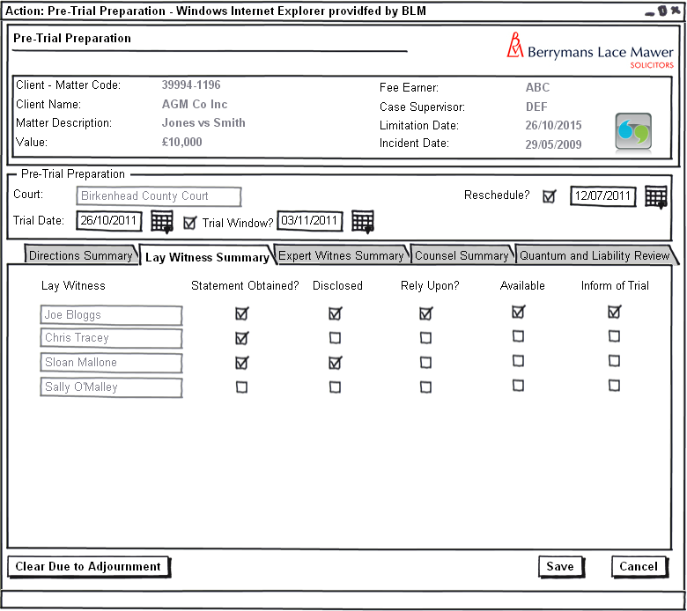
    - Pre-Trial Preparation – Lay Witness Summary Tab

Figure 2 – Pre-Trial Preparation – Lay Witness Tab

The lay witness section detailed above will allow the user to visually check off those lay witnesses that have provided a statement, whether they can be relied upon and subsequently if they should be informed of trial. Tab should be invisible if there are no lay witnesses associated with the matter.

Form Behaviour On Load

The form should load with each lay witness listed with the following details:
- Statement Obtained.
- Disclosed?
- Rely Upon?
- Available.
- Inform of Trial
pre populated via a new stored procedure LTMM_PreTrialPrepContact_Fetch.

Form Items

The following form items should be repeated on the form for each lay witness associated with the matter.
Lay Witness – Label as stated with associated read only textbox displaying the name of the lay witness.
Statement Obtained – Label as stated with associated checkbox.
Disclosed? – Label as stated with associated checkbox.
Rely Upon? – Label as stated with associated checkbox.
Available – Label as stated with associated checkbox.
Inform of Trial – Label as stated with associated checkbox.
Clear Due to Adjournment – Label as stated with associated button that has many uses on this screen but specifically on this tab it should clear all the checkboxes associated with each lay witness in the event of the user clicking on the button.

Form Behaviour on Submit

Use New Stored Procedure LTMM_PreTrialPrep_Save to save the following details entered on the form:
- The following information for each lay witness:
  - Statement Obtained.
  - Disclosed?
  - Rely Upon?
  - Available.
  - Inform of Trial

    - Pre-Trial Preparation – Expert Witness Summary Tab

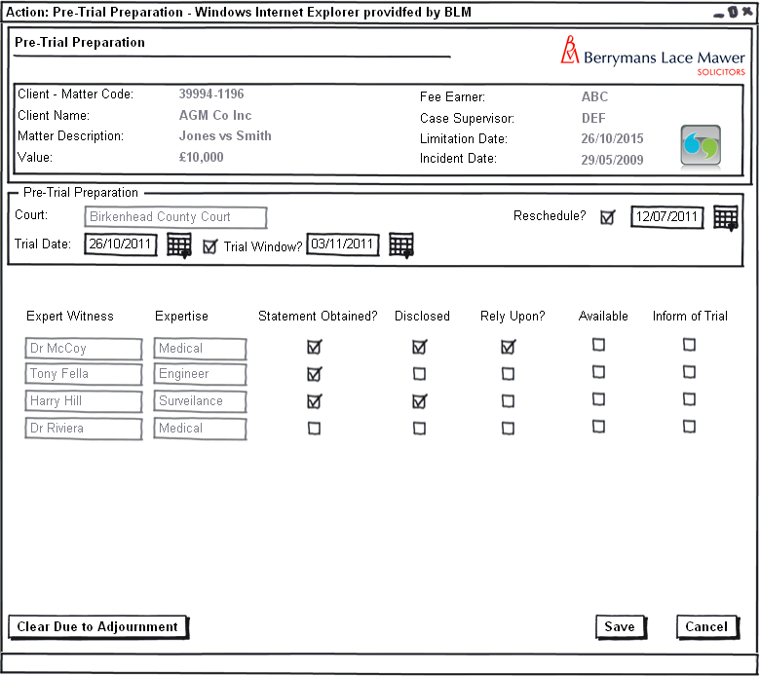
Figure 3 – Pre-Trial Preparation – Expert Witness Tab

The expert witness section will allow the user to review any expert witnesses that are attached to the matter, these witnesses can then be assessed in terms of their field of expertise if any evidence provided has been disclosed if they are required to give oral evidence and then subsequently if they are to be informed of the trial.

Form Behaviour On Load

The form should load with each Expert witness listed with the following details:
- Statement Obtained.
- Disclosed?
- Rely Upon?
- Available.
- Inform of Trial
pre populated via a new stored procedure LTMM_PreTrialContact_Fetch.

Form Items

The following form items should be repeated on the form for each expert witness associated with the matter.

Expert Witness – Label as stated with associated read only textbox displaying the name of the Expert witness.
Expertise – Label as stated with associated read only textbox displaying the field of the Expert witness.
Statement Obtained – Label as stated with associated checkbox.
Disclosed? – Label as stated with associated checkbox.
Rely Upon? – Label as stated with associated checkbox.
Available – Label as stated with associated checkbox.
Inform of Trial – Label as stated with associated checkbox.
Clear Due to Adjournment – Label as stated with associated button that has many uses on this screen but specifically on this tab it should clear all the checkboxes associated with each expert witness in the event of the user clicking on the button.

Form Behaviour on Submit

Use New Stored Procedure LTMM_PreTrialPrep_Save to save the following details entered on the form:
- The following information for each expert witness:
  - Statement Obtained.
  - Disclosed?
  - Rely Upon?
  - Available.
  - Inform of Trial

    - Pre-Trial Preparation – Counsel Summary Tab

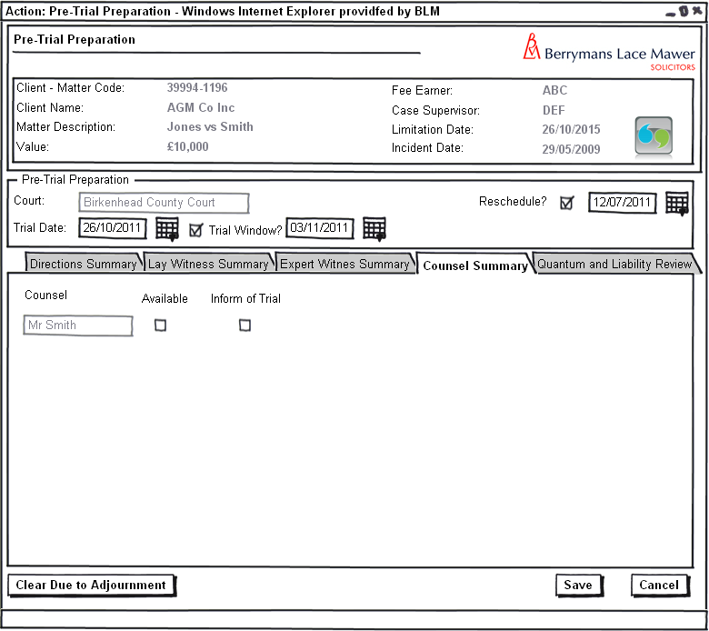
Figure 4 – Pre-Trial Preparation – Counsel Summary Tab

The counsel section will allow the user to review any counsel that are attached to the matter and if they are available and informed of the trial.

Form Behaviour On Load

The form should load with each counsel listed with the following details:
- Available.
- Inform of Trial
pre populated via a new stored procedure LTMM_PreTrialPrepContact_Fetch.

Form Items

The following form items should be repeated on the form for each Counsel associated with the matter.

Counsel – Label as stated with associated read only textbox displaying the name of the Expert witness.
Available – Label as stated with associated checkbox.
Inform of Trial – Label as stated with associated checkbox.
Clear Due to Adjournment – Label as stated with associated button that has many uses on this screen but specifically on this tab it should clear all the checkboxes associated with each counsel in the event of the user clicking on the button.

Form Behaviour on Submit

Use New Stored Procedure LTMM_PreTrialPrep_Save to save the following details entered on the form:
- The following information for each counsel:
  - Available.
  - Inform of Trial

    - Pre-Trial Preparation – Quantum and Liability Review Tab

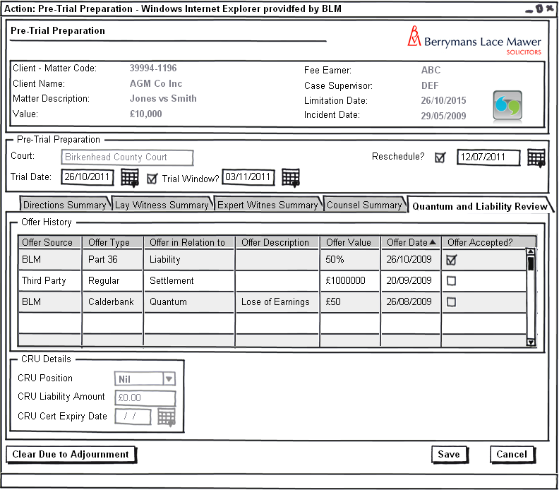Figure 5 – Pre-Trial Preparation – Quantum and Liability Review Tab

The Quantum and Liability review section will allow the user to review all the offers attached to the system and the CRU details

Form Items

Offer History - Grid listing all offers attached to the matter. Grid should be populated via the existing stored procedure LTMM_Offers_Fetch.
CRU Position – Label as stated with associated read only textbox showing the current CRU position on the matter (via the stored procedure LTMM_ClaimantCRU_Fetch).
CRU Liability Amount – Label as stated with associated read only textbox showing the current CRU liability amount on the matter (via the stored procedure LTMM_ClaimantCRU_Fetch).
CRU Cert Expiry Date – Label as stated with associated read only textbox showing the current CRU Cert Expiry Date on the matter (via the stored procedure LTMM_ClaimantCRU_Fetch).
Clear Due to Adjournment – Label as stated with associated button that has no functionality relating to this tab.

CRU Note – Obviously the CRU is technically attached to each claimant on the matter but there should only be 1 claimant per matter this scope assumes this to be true and should just default to the first claimant on the matters CRU details.

  - Record Trial Result

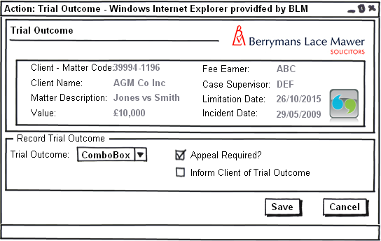
Figure 6 – Trial Outcome result

Form Availability

This form will be scheduled only from the Pre Trial Preparation task detailed in section 3.1. This form should not be available adhoc from the case actions screen.

Form Behaviour On Load

The form should load with no data pre-populated.

Form Items

Trial Outcome – Label as stated with associated Mandatory Combo box having the following options (Populated using LTMM_LookupCodes_Fetch with @LookupTypeCode = 'TRLOTCM’, @BlankRow = 1):
- BLM
- Third Party

Appeal Required? – Label as stated with associated checkbox denoting if an appeal is required or not (Checked = Required).

Inform Client of Trial Outcome – Label as stated with associated checkbox denoting if we need to inform client of trial result or not (Checked = Inform).

Form Behaviour on Submit

Should return to the matter landing page.
If Trial Outcome = ‘BLM’ write history line “Trial Outcome in favour of BLM”
If Trial Outcome = ‘Third Party’ write history line “Trial Outcome in favour of Third Party”
If Appeal Required? <> ‘’ write history line “Appeal to Trail outcome to be lodged”

If Appeal Required? <> ‘’ set all active directions attached to the matter as inactive.

If Inform Client of Trial Outcome <> ‘’ produce adhoc letter to the client for the user to edit.

Form Behaviour on Cancel

Should return to the matter landing page.

Workflow

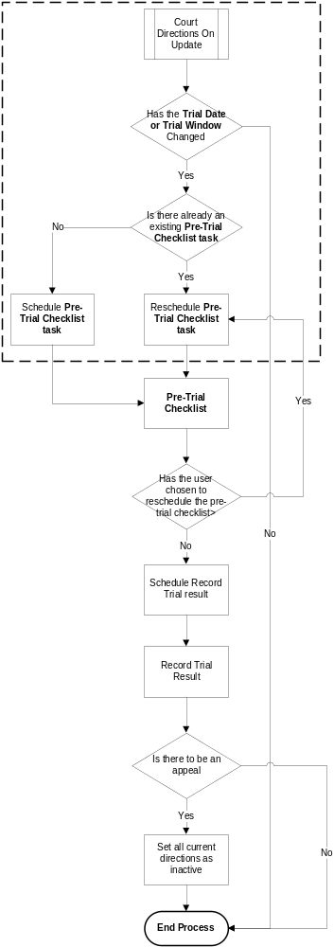

Navigation

Where will the Flow be launched from

The Flow will originate from the Court Directions and is instigated when a Change is made to the Trial date or Trial Window.

Where should the Flow return to

The Flow should return to the matter landing page.

SQL Tables

Table

The following new table structure is required to accommodate the pre-trial preparation.

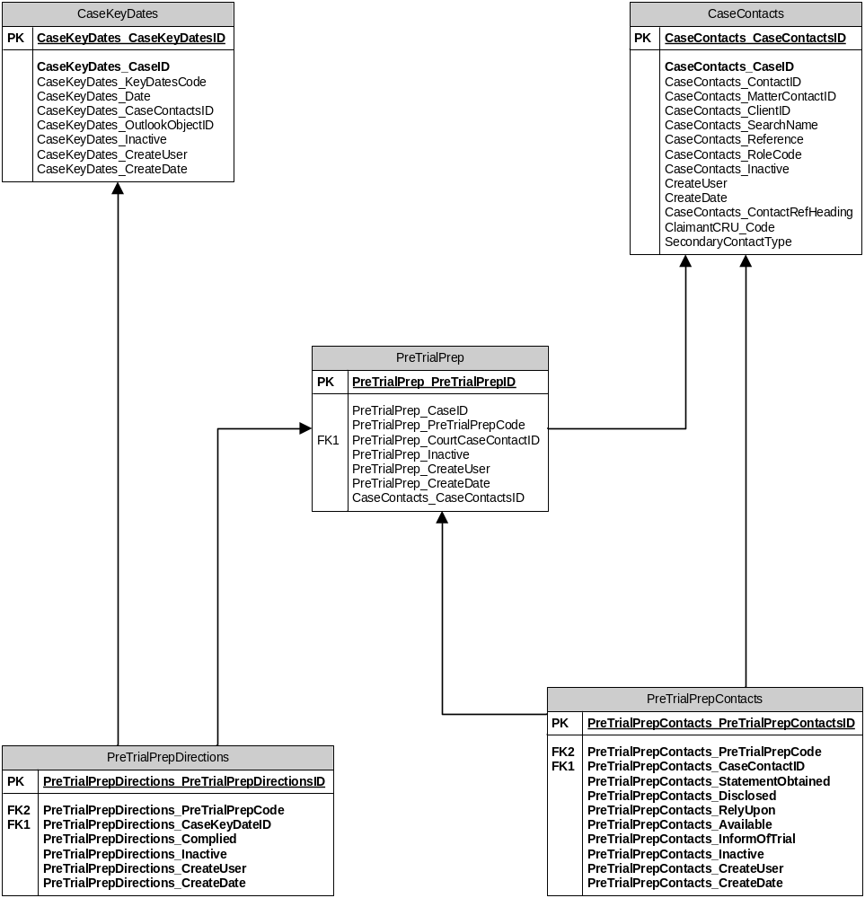

This new table structure has the following new table definitions:

New table PreTrialPrep with the following new columns

PreTrialPrep_PreTrialPrepID type int IDENTITY(1,1)

PreTrialPrep_CaseID type int

PreTrialPrep_PreTrialPrepCode type nvarchar](255)

PreTrialPrep_CourtCaseContactID type int

PreTrialPrep_Inactive type bit

PreTrialPrep_CreateUser type nvarchar(255)

PreTrialPrep_CreateDate type smalldatetime

New table PreTrialPrepContacts with the following new columns

PreTrialPrepContacts_PreTrialPrepContactsID type int IDENTITY(1,1)

PreTrialPrepContacts_PreTrialPrepCode type varchar(255)

PreTrialPrepContacts_CaseContactID type int

PreTrialPrepContacts_StatementObtained type bit

PreTrialPrepContacts_Disclosed type bit

PreTrialPrepContacts_RelyUpon type bit

PreTrialPrepContacts_Available type bit

PreTrialPrepContacts_InformOfTrial type bit

PreTrialPrepContacts_Inactive type bit

PreTrialPrepContacts_CreateUser type varchar(255)

PreTrialPrepContacts_CreateDate type smalldatetime

New table PreTrialPrepDirections with the following new columns

PreTrialPrepDirections_PreTrialPrepDirectionsID type int IDENTITY(1,1)

PreTrialPrepDirections_PreTrialPrepCode type varchar(255)

PreTrialPrepDirections_CaseKeyDateID type int

PreTrialPrepDirections_Complied type bit

PreTrialPrepDirections_Inactive type bit

PreTrialPrepDirections_CreateUser type varchar(255) PreTrialPrepDirections_CreateDate type smalldatetime

Lookup

Trial Outcome – Label as stated with associated Mandatory Combo box having the following options (Populated using LTMM_LookupCodes_Fetch with @LookupTypeCode = 'TRLOTCM’, @BlankRow = 1):
  - BLM
  - Third Party

Field

n/a

Stored Procedures

Fetch

New stored procedure LTMM_PreTrialContact_Fetch required fetching all the contact trial details of a given matter:
Inputs:
  - @pCaseID– int – mandatory use the caseid associated with this matter.
  - @pPreTrialPrepCode - nVarchar(10) used to fetch existing details
  - @pUsername – nvarchar(255) – mandatory use system.username within Flosuite
Outputs
  - PreTrialPrepContactsID – For reference only
  - CaseContactID – For reference only
  - ContactName – Map to the Contact Name in the Contact Summary Grids on the Pre Trial Checklist
  - PreTrialPrepContacts_Expertise – Map to the Expertise in the Contact Summary Grids on the Pre Trial Checklist
  - PreTrialPrepContacts_StatementObtained – Map to Statement Obtained in the Contact Summary Grids on the Pre Trial Checklist
  - PreTrialPrepContacts_Disclosed – Map to Rely Upon in the Contact Summary Grids on the Pre Trial Checklist
  - PreTrialPrepContacts_RelyUpon – Map to Evidence Disclosed in the Contact Summary Grids on the Pre Trial Checklist
  - PreTrialPrepContacts_Available – Map to Available in the Contact Summary Grids on the Pre Trial Checklist
  - PreTrialPrepContacts_InformOfTrial – Map to Informed of Trial in the Contact Summary Grids on the Pre Trial Checklist
  - PreTrialPrepContacts_Inactive – For reference only
  - PreTrialPrepContacts_CreateUser – For reference only
  - PreTrialPrepContacts_CreateDate – For reference only
  - ContactType – For reference only

New stored procedure LTMM_PreTrialPrepDirections_Fetch required fetching all the contact trial details of a given matter:
Inputs:
  - @pCaseID– int – mandatory use the caseid associated with this matter.
  - @pPreTrialPrepCode - nVarchar(10) used to fetch existing details
  - @pPreTrialPrep_CourtCaseContactID – The CaseContactID for the trail court used to retrieve the directions associated with that court
  - @pUsername – nvarchar(255) – mandatory use system.username within Flosuite
Outputs
  - Direction Description – Map to the Direction Description in the Directions Summary Grids on the Pre Trial Checklist
  - Due Date – Map to the Due Date in the Directions Summary Grids on the Pre Trial Checklist
  - Complied With – Map to the Complied With in the Directions Summary Grids on the Pre Trial Checklist
  - CaseKeyDates_CaseKeyDatesID – For reference only

New stored procedure LTMM_PreTrialPrep_Fetch required fetching all the contact trial details of a given matter:
Inputs:
  - @pCaseID– int – mandatory use the caseid associated with this matter.
  - @pPreTrialPrepCode - nVarchar(10) used to fetch existing details
  - @pPreTrialPrep_CourtCaseContactID – The CaseContactID for the trail court used to retrieve the directions associated with that court
  - @pUsername – nvarchar(255) – mandatory use system.username within Flosuite
Outputs
  - Court – Map to Court on the Pre Trial Checklist
  - Trial Date – Map to Trial Date on the Pre Trial Checklist
  - Trial Window – Map to Trial Window on the Pre Trial Checklist
  - Trial Window Start Date – Map to Trial Window Start Date on the Pre Trial Checklist
  - Trial Window End Date – Map to Trial Window End Date on the Pre Trial Checklist

Save

New stored procedure LTMM_PreTrialPrep_Save required attaching a Pre-Trial Preparation details to a given matter:
Inputs:
  - @pPreTrialPrepCode
  - @pCase_Caseid – nvarchar(10) – mandatory use the Case_Caseid attached to the matter at inception.
  - @pPreTrialPrep_CourtCaseContactID – int – Court CaseContactID of the Court associated with the process
  - @pDirectionsGridInput – nvarchar(max) – XML Inputs from the direction grid
  - @pContactInput – nvarchar(max) – XML Inputs from the Contact screens
  - @pTrialDate – smalldatetime – Map to Trial Date
  - @pTrlWndw – bit – Map to Trail Window
  - @pTrlWndwSrt – smalldatetime – Map to Trial Window Start Date
  - @pTrlWndwEnd – smalldatetime – Map to Trial Window End Date
  - @pUserName – nvarchar(10) – mandatory use the system username
Outputs
  - @pPreTrialPrepCode – nvarchar(255)

Document Templates

Please list below details of any document required as part of this scope.

Status:  New / Existing / Replacement  (please state) | Received Document Name (from business) | Document File Name  (ie Document.dot) | Document Description  (as viewed on FloCase) | Template Description Code  (Code for auto description) | Template Group:  BLM/ Documents/ Court Doc/ Letters/ Other  (Please State)
Existing | Adhoc letter to Client | BLM_Letter.dot | BLM Letter Template | Ltr. | BLM

/tmp/lo/0000.doc

